4.6 Onlevel Graphing Quadratic Functions EXAM 1
Name:_______________________
- ${y=x}^{2}-4x-5$ |  |  |  |  |  | 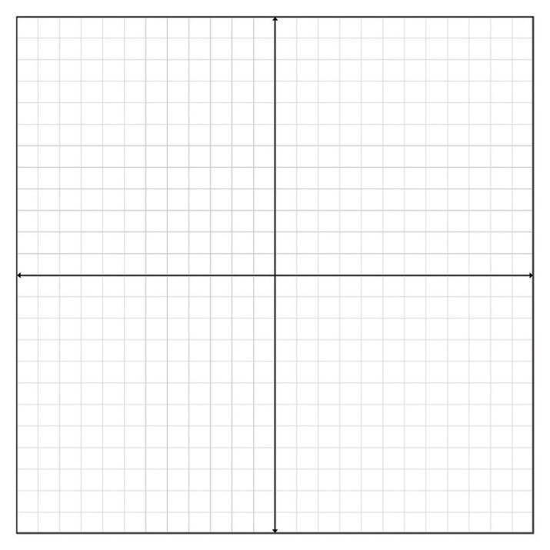
Max/Min |  |  |  | axis of symmetry
Find the vertex form: $y=a(x-h)^{2}+k$
Use $h=\frac{-b}{2a}$

 |  |  |  |  |  | x intercept(s):
y-intercept: |  |  | Vertex:
 |  |  |  |  |  | Range | Domain:

4. List the transformations for the following Quadratic:
$f(x)=4(x+3)^{2}-1$
_______________________________________________________________________________

5. Write the equation in vertex form for the following transformations:
Up 3, left 6, Compressed vertically by $\frac{1}{4}$ and reflected over the $x-axis$
_____________________________________

- $y=-x^{2}-2x-3$ |  |  |  |  |  | 
Max/Min |  |  |  | axis of symmetry
Vertex Form: Use $h=\frac{-b}{2a}$ , $y=a(x-h)^{2}+k$

 |  |  |  |  |  | x intercept(s):
y-intercept: |  |  | Vertex:
 |  |  |  |  |  | Range | Domain:

4.6 Onlevel Graphing Quadratic Functions EXAM 2
Name:______________________
- $y= -x^{2}-2x-3$ |  |  |  |  |  | 
Max/Min |  |  |  | axis of symmetry
Vertex Form: $h=\frac{-b}{2a}$, $y=a(x-h)^{2}+k$

 |  |  |  |  |  | x intercept(s):
y-intercept: |  |  | Vertex:
 |  |  |  |  |  | Range | Domain:

- List the transformations for the following Quadratic:
$f(x)= -\frac{1}{4}(x+3)^{2}-1$
_______________________________________________________________________________

- Write the equation in vertex form for the following transformations:
Down 3, left 6, stretches vertically by 4 and reflected over the $x-axis$
_____________________________________

- ${y=x}^{2}-4x-5$ |  |  |  |  |  | 
Max/Min |  |  |  | axis of symmetry
Vertex Form: $h=\frac{-b}{2a}$, $y=a(x-h)^{2}+k$

 |  |  |  |  |  | x intercept(s):
y-intercept: |  |  | Vertex:
 |  |  |  |  |  | Range | Domain:

